A Positive Proof:

That

Thomas Fitzwater was not an only child;

That

John Fitzwater, Jr. was a biological son of John Fitzwater, Sr;

And Overall

A Refutation of Numerous Errors Concerning Them Contained in *Fitzwater Families of America*

Written by

Victoria Hopkins Kahn

In collaboration with

Leslie Lawson’s

Proposed FTDNA Fitzwater Surname Project

July 4, 2013

copyright 2013 Victoria Kahn

Published by Victoria Kahn: Escondido, CA, 2013

This Manuscript may be reproduced if proper credit is given and no changes are made.

*With*

*Special Thanks to:*

Sandra Elkins,

Researcher in Rockingham for the

Augusta County Genealogical Society, Fishersville, VA;

Chris Kolbe,

Archives Research Coordinator,

Library of Virginia, Richmond, VA;

William C Luebke,

Reference Librarian,

Library of Virginia, Richmond, VA;

Kent Olson,

University of Virginia, Law Library, Charlottesville, VA

JoAnn Pendley,

Secretary,

Augusta County Genealogical Society, Fishersville, VA;

Introduction

I encountered my cousins, Leslie Lawson and her uncle, David Fitzwater, when the Family Finder project at Family Tree DNA correctly matched us genetically, leaving us to name our connection along the paper trail. This was easily done, as we had all arrived at the point of our mutual descent from John Fitzwater, Jr. and his wife, Charity Humble who married on July 9, 1785, in Rockingham County, VA.

The likelihood that John Fitzwater, Jr. was the son of John Fitzwater, Sr. and his wife, Judith West Fitzwater arose in our discussions. At this point Leslie made me aware of the publication of *Fitzwater Families of America* by Katheryn Fitzwater Devine. Devine had made argument, seemingly based upon historical record, that this obvious familial relationship was not the case, and had stated forcefully that Thomas was the only off spring of John and Judith Fitzwater. She further surmised that John Fitzwater, Jr. was an orphan or other unrelated person brought into the household.

I was amazed at this posture and began looking for documents that would prove otherwise. Devine states on page 26 of her current work that she provides reference to a series of easily obtainable extracted documents that *prove* Thomas was an only child. It is these very documents, among others, that prove her egregious error.

This manuscript deals only with proving that Thomas was not an only child, and that John Fitzwater, Jr is, indeed, the biological son of John Fitzwater, Sr., therefore all the documents cited by Devine that relate to other issues have not been included in this proof, and may yet be in error. Certainly any and all unsupported claims made by her and those based upon the Chalkley extractions require further research.

It has always been my method to obtain and review as many original documents as possible when positing a genealogical proof, rather than relying on secondary, or even more remote sources, in order to assure the greatest degree of accuracy within each record.

What began as a simple genealogical proof became a foray into law history and study of applied law in Colonial Virginia.

“The laws of a country are necessarily connected with everything belonging to the people of it; so that a thorough knowledge of *them* and of their progress, would inform us of everything that was most useful to be known about them; and one of the greatest imperfections of historians in general, is owing to their ignorance of the law.” Priestley’s Lecture on History, Vol. I, pa. 149, as quoted by William Waller Hening on The Statutes at Large; being a collection of all the laws of Virginia from the first session of the legislature in the year 1619; New York; 1819; published by R&W&G Bartow 1823.

I then came across a posting by Devine on Genealogy.com challenging anyone with “positive proof” to please post it. This humble manuscript is my answer to her challenge.

Leslie took another approach, by suggesting we create a Fitzwater Surname Project at Family Tree DNA; ask male Fitzwaters to submit DNA for comparison with David’s; and by so doing, conclusively prove common descent from John Fitzwater, Sr.

This manuscript is now complete, and I am confident that our true, biological, and natural descent from John Fitzwater, Sr. and Judith West Fitzwater is proved. However, I support the development of Leslie’s proposed Fitzwater Surname Project at Family Tree DNA. The project is seeking male Fitzwater participants. Anyone eligible wishing to participate is welcome. Please contact Family Tree DNA at [www.ftdna.com](http://www.ftdna.com) . DNA supporting the documentary proof of this paper will surely remove all doubt whatsoever.

Table of Contents

A Special Thanks 2

Introduction 3

Table of Contents 5

Thomas Fitzwater was not an only child 6

John Fitzwater, Jr. was a biological son of John Fitzwater, Sr. 12

Appendix:

Section 1: Document 1: original deed of 130 acres *face* side 17

Document 1: original deed of 130 acres *signature* side 18

Document 2: original deed of 46 acres *face* side 19

Document 2: original deed of 46 acres *signature* side 20

Section 2: Document 1 Fitzwater/Humble marriage bond 21

Document 2 Fitzwater/Humble marriage consents 22

Document 3 Shanklin/Rader marriage bond & consents 23

Document 4 Bridwell/Kidd marriage bond & consents 24

Document 5 Bruffy/Ireland marriage bond & consents 25

Document 6 Davis/Herring marriage bond & consents 26

Document 7 Effinger/Hite marriage bond & consents 27

Document 8 Lewis/Robinson marriage bond & consents 28

Section 3: Document 1 Minute Book transcription 29

Document 2 Minute Book original handwritten 30

Bibliography 31

Thomas Fitzwater was not an only child:

It is right and proper to first dispel the erroneous notion that Thomas Fitzwater, the son of John Fitzwater, Sr. and Judith West Fitzwater, was an only child as asserted so forcefully by Katheryn Fitzwater Devine in *Fitzwater Families of America, pp26-29.* She bases her assertion on several Court Minute and Order Book transcriptions and upon two land deeds, both part of an extraction of a lawsuit adjudicated in Augusta County, VA, in 1825, *Stultz v McKinsie’s Executor’s-- O.S. 353; N.S. 182*, which appear to have been further extracted by Devine, from Lyman Chalkley’s publication *Chronicles of the Scotch-Irish Settlement in Virginia Extracted from the original Court Records of Augusta County, 1745-1800 (Rosslyn, VA. 1912-1913 pp. 247-248).*

The original deed for the 130 acre parcel appearing in Chalkley’s extractions was obtained from the online Chancery Records Index, in Virginia Memory, of the Library of Virginia, and a copy is appended herewith as *Appendix: Section 1, Document 1*. This deed comprises an Indenture of Bargain and Sale dated 5 February 1799, between Judith Fitzwater, “widow and relict of John Fitzwater”, and Thomas Fitzwater and Mary Fitzwater his wife “heir apparent at law of the said John Fitzwater”, of the one part, and Thomas McKinsie of the other part. The document has, *until now*, been erroneously quoted (based upon Judge Chalkley’s incomplete extraction which was carried forward by Devine) as stating that the intestate inheritance was divided so that “1/3 goes to the widow and 2/3 goes to the ‘heir at law’”. Thus it becomes easy to recognize how a material misunderstanding came into being, as a result of this language, and has been perpetuated by many who relied upon that extraction without examining the original—a serious mistake in research methods.

The document actually reads, “…the fee Simple Estate of and in the one third part of the aforesaid Certain tract or parcel of land descends unto the said Judith Fitzwater, widow and relict of the said desceadent, during her life, and the remaining two thirds unto the aforesaid Thomas Fitzwater, as **Eldest son and as Heir at law** of the said John Fitzwater, deseasing.”

Prior to their publication Lyman Chalkley’s notes and typescript had been examined by several experts on behalf of the National Society of the Daughters of the American Revolution who Chalkley had approached as a publisher. Both were found to be filled with errors including material omissions, such as the error in the extraction of the language of the actual text of the Indenture of Bargain and Sale brought to light above concerning the title under which Thomas Fitzwater inherited after the decease of his father. Daphne Gentry, from the Library of Virginia, discusses the said examination and its findings as part of a series of online articles about “Research in Virginia Documents”:

Chalkley's Chronicles (VA-NOTES)

Lyman Chalkley's three-volume *Chronicles of the Scotch-Irish Settlement in Virginia Extracted from the Original Court Records of Augusta County, 1745-1800* (Rosslyn, Va., 1912-1913; reprint, 1965)  is a popular reference work that contains abstracts taken from the Augusta County court records. Chalkley's *Chronicles* may serve as a useful source for leads and to identify original records to consult, but there are many reasons to exercise caution when using it.

Before the publication of the *Chronicles*, the National Society of the Daughters of the American Revolution, which had been approached to become the publisher, commissioned genealogist and historian Thomas Forsythe Nelson to make an analysis of the work. Nelson's detailed evaluation, in which the Society as well as Herbert Putnam, who was then the Librarian of Congress, and historian J. Franklin Jameson all concurred, was that the typescript of Chalkley's abstracts that had been submitted should not be published. Nelson found that the abstracts contained an abundance of transcription errors, erroneous dates, misspelled names, material omissions, and other serious mistakes. He concluded that the abstracts were "condensed to the point of mutilation" and that many entries misrepresented the contents of the original documents.

Nelson also pointed out that Chalkley had abstracted only some of the records that pertained to persons and families in which he was interested. Publication of the abstracts could easily lead to the erroneous conclusion that the absence in the abstracts of information about a person or a family meant that there was no information on the person or family in the county court's records.

Nelson's whole report, containing detailed comparisons between Chalkley's abstracts and the original records, was published as a substantial pamphlet under the authority of the 21st Congress, National Society, Daughters of the American Revolution (Washington, D.C., 1912) with the title *Report on the Chalkley Manuscripts.*

Mary Smith Lockwood, an honorary vice-president-general of the Society, nevertheless proceeded on her own to have the typescript of Chalkley's abstracts published in the familiar three-volume edition.

Many users have no doubt concluded wrongly, as Nelson predicted, that the absence of references in Chalkley's *Chronicles* indicated a lack of data; and many other users have certainly been mislead by using Chalkley's faulty abstracts and not consulting the original records. Chalkley's *Chronicles* can be a valuable resource if it is used as a first finding aid for citations but not as a correct reproduction or representation of the full rich entries in the county court's original manuscript records.

An online series on Research in Virginia Documents.  
Prepared by Daphne Gentry, Publications and Education Services Division.  
Copyright by The Library of Virginia; this note may be reproduced in full if proper credit is given and no changes are made.

Library of Virginia, 800 East Broad Street, Richmond, Virginia 23219-800

Thomas Forsythe Nelson, in his *Report on the Chalkley Manuscripts*, relates on page 2, that the extreme condensation of the records in Chalkley manuscripts results in language that leaves the real facts open to misinterpretation or creates a different meaning all together. He goes on to reveal a notable example of Judge Chalkley’s extraction style on page 17, wherein Chalkley selected only one item of about seven words from within 46 well filled pages of the court record book, *omitting* everything else on those 46 pages. Nelson concludes that the manuscripts are not ready for publication. The “Report on the Chalkley Manuscripts” by Thomas Forsythe Nelson can be found in hard copy on the shelves of the Library of Virginia, in microform in various university libraries, and online in Heritage Quest. Clearly, Devine has misinterpreted the 130 acre Fitzwater deed.

Devine perpetuates another such omission by quoting Chalkley when he writes that the second Indenture of Bargain and Sale from Thomas and Mary Fitzwater to Thomas McKensie for 46 acres, showing Thomas inherited as “Only and Sole Heir” of his father, when the actual document states he inherited as “Only and Sole Heir at Law*”(Appendix, Section 1, Doc.2)*.

The first Indenture of Bargain and Sale of the 130 acres, describes Thomas, in its first paragraph, as “heir apparent at law” and then, midway down the page, “as Eldest son and as Heir at Law”. Black’s Law Dictionary, page 723, defines the *legal* *term* “Heir apparent” by saying “An heir whose right of inheritance is indefeasible, provided he outlive his ancestor; as in England the eldest son, or his issue, who must by the course of the common law, be heir to the father whenever he happens to die.” The *legal term* “heir at law” is defined as “At common law, he who, after his ancestor dies, has a right to all lands, tenements, and hereditaments, which belonged to him, or of which he was seized.” and “A deceased persons ‘heirs at law’ are those who succeed to his estate of inheritance under statutes of descent and distribution, in absence of testamentary disposition, and not necessarily his heirs at common law, who are persons succeeding to deceased’s realty in case of his intestacy.”

Author C Ray Keim in his article *Primogeniture and Entail in Colonial Virginia*, states on pages 549-550, that any lands held in entail previously were “*ipso facto* seized” in fee simple as of Oct 7, 1776, with the advent of Thomas Jefferson’s law. However, the primogeniture inheritance law in intestacy remained in place at that time.

Language used by the Court under Primogeniture law, indicative of an “only child” appears in Hening’s Statutes at Large, the Laws of Virginia—Aug, 1754—28 George II, “An Act to dock the intail on certain lands wherein Nathaniel West Dandridge, gentleman, is seised, and for settling other lands and slaves of greater value to the same uses”, on page 429, wherein the heir is described as “his only child and heir of his body”.

In direct contradiction of Devine’s unsupported assertion, on her page 28, that it did *not*, Primogeniture *did, indeed,* provide a one third part dower for widows. Hening’s Statutes at Large, Laws of Virginia, October 1748—22 George II, “An Act for the Distribution of Intestate Estates”, page 448, states “…That the widow of every person dying intestate, shall be endowed of one full and equal third part of all her husband’s lands, tenements, and other real estate, in manner as is directed and prescribed by the laws and constitutions of the kingdom of England;…”

The Library of Virginia states in its *Instructions for Using County and City Court Records in the Archives* that “Under Primogeniture, Virginia wills may not always *name* [emphasis is the instant author’s]the wife or the eldest son of the testator. Their inheritance of real estate was set by law, the widow receiving her dower, or one-third for her lifetime and the eldest son, as heir at law, receiving the remaining two-thirds unless otherwise specified in the father’s will.”

Both the legal definitions in Black’s Law Dictionary and the descriptions of inheritance under Primogeniture are clear that this proportioning applies only to real estate. Since, the documents preserved here are land transactions, they make perfect sense.

A study of *The Statutes at Large; Being a Collection of All the Laws of Virginia from the First Session of the Legislature in the year 1619,* pursuant to the Act of the General Assembly of Virginia, on 5 February 1808, by William Waller Hening, reveals in “An act directing the course of descents” by virtue of the clause “XVIII: This act shall commence and be in force at and after the first day of January, one thousand seven hundred and eighty-seven” , that although the Statutes which effectually ended the practice of Primogeniture in Virginia were part of the legislation titled the “Laws of Virginia, October 1785—10th of the Commonwealth”, they did not enter into force until January 1, 1787.

This date for the new law is reiterated by the footnote to “C.96 An Act to reduce into one, the several acts directing the course of descents”, which states “…All the provisions of this act which are referred to as having been originally enacted by act of 1785, c.60, took effect by the commencing clause of that act, on the first of January, 1787.”, contained in *The Revised Code of the Laws of Virginia: Being a Collection of All Such Acts of the General Assembly, of a Public and Permanent Nature, as are Now in Force; with a General Index…,*printed by Thomas Ritchie in 1819.

This date for the ending of Primogeniture becomes exceedingly important in that it refutes the unsupported statement made by Devine on page 28 of *Fitzwater Families of America* that Primogeniture in Virginia had long been abolished when Judith and her son Thomas Fitzwater appeared in Court on January 22, 1787, and were granted administration—meaning the right to administer— for the estate of the deceased and intestate John Fitzwater, Sr.. [Page 681, in the transcribed Minute Book 1786-1791 Rockingham County, VA.] ***Not only was******primogeniture******not******abolished long****,* ***but******the new law******had only******been in force for 22 days!***

Devine prints a sentence on her page 26, without reference to its source [although the number 88 appears above and behind it in superscript] in reference to John Fitzwater, Sr., which conveys that he died in Rockingham County, VA, in 1786, having attained 61 years of age.

Although, no documents stating John’s actual death date have yet been discovered, through an analysis of the information involving how his real estate was inherited, the deeds, the dates the statutes went in and out of force, and the accumulated body of Court Minute and Order Books, and other records, it can be shown that John Fitzwater, Sr., did, indeed, die late in the month of December in 1786.

The records of the Order Book of Rockingham County, VA, 1783-1792, contain an entry on 27 March 1785, that John Fitzwater, Sr., is exempted from paying the county levy by reason of his infirmity of body.

The Virginia Supreme Court District of Kentucky Order Books 1783-1792 (transcribed) record on page 56 that on June 21, 1785, John Fitzwater was an inhabitant of Rockingham County, Virginia, and very infirm.

Hening’s Statutes at Large, under the “old” primogeniture law titled Laws of Virginia, November 1711—9th Anne, “An Act Directing the Manner of Granting Probate of Wills and Administration of Intestate Estates”, on p.15, [although there is no upward time limit for kindred to come forward] advise that if no will is presented or some motion made for legal proceedings by the kindred of the deceased, administration may be granted to any person after 30 days has expired.

Again, in Hening’s Statutes at Large, Laws of Virginia, October 1785—10th of the Commonwealth, “An Act directing the course of descents”, p. 147, that if no kindred “applies for administration within thirty days from the death of an intestate, the court may grant administration to any creditor or creditors who apply for the same, or any other person the court in their discretion shall think fit:..”.

Since no creditors or other persons seem to have come forward for administration, it would appear that Judith and Thomas Fitzwater must have come before the court within 30 days of the death of John Fitzwater, Sr..

Viewed in the light of the above laws and records, and compared with the probate records of other intestate individuals (for example, the record of Leman Hopkins who died in Audrain, County, Missouri, on 30 April, 1905, and whose heirs were granted administration on 25 May, 1905—a time factor of 25 days) we find it is absolutely reasonable for John to have actually died at any time between December 24th and December 31st, 1786, and his heirs to still have been within the 30 day time frame when they appeared in Court on January 22, 1787.

Also in *Instructions for Using County and City Court Records in the Archives* the Library of Virginia instructs patrons that “Virginia did not require the filing of estate papers documenting each activity of the executor. The assumption was made that the executor settled the estate as directed by will and by the law, and no records were created if the work was done correctly. Consequently, Virginia has no *estate packets* or *probate packets*. If the executor did not act correctly, the offended party could bring suit in chancery.” [See Hening’s Statutes at Large, Laws of VA—November, 1711—9th Anne, “An Act Directing the Manner of Granting Probate of Wills…”, pg 20] No suit against this estate has yet been found on any record.

When Judith and Thomas are “granted administration” the court continues on to state “they having complied with the law”—meaning they had filed an administration bond. Indeed, a bond record is on file and appears on page 22 in *Abstracts of Executors, Administrator, and Guardian Bonds of Rockingham County, Virginia 1778-1864* compiled by Marguerite B. Priode. This bond is dated Jan. 22, 1787, and shows a sum of 500 Pounds [dollars?] paid by Conrad Humble and William Fitzwater on behalf of Judith Fitzwater and Thomas Fitzwater.

Interestingly, although the name Fitzwater never appears in the index to the aforementioned volume, a line by line search of the contents reveals that a Fitzwater appears in 3 entries on page 1; in 1 entry on page 11; in 1 entry on page 21; and finally in the abovementioned entry on page 22; making a total of 7 separate bonds---none of which is a Guardian Bond.

Further evidence that John Fitzwater, Sr., did indeed die—most likely in late December--in 1786, within the 30 day time frame for administration, while Primogeniture was still in effect is produced by the Virginia Supreme Court of Appeals, when it considered the question of inheritance in just such cases as this of Fitzwater, in the *Case of Dickenson and others v. Holloway*, decided on Oct 29, 1819. The court ruled that the law in effect at the time of a person’s death was the law under which the estate would be administered, rather than any law commencing at a later date. Their conclusion was: *“But it is contended that the Act of Descents has now made a difference, and lets in the claim of the present appellants. That cannot be, as both John Holloway and George Holloway died before it’s commencement, unless the Act is to have a retrospective operation. Such a construction is reprobated, 1st, by the general principle that all law, or at least all which concern rights, are only prospective in their nature; 2dly, that that Act is declared to commence it’s operation from and after a future and given day; and the Court is of the opinion that these words, “from and after, &c.” are to be considered as if they were set out and repeated in the commencement of every section of the Act; and 3dly, that this is emphatically the case in relation to this Act; it declaring that “henceforth” when any person, &c., shall die intestate &c.” plainly excluding from it’s operation cases of deaths before the commencement of the Act. That Act therefore is not to be regarded, in making a construction, in the case before us: the appellants can in no case be regarded as heirs, but in relation to ancestors dying after the commencement of the Act.”* [See Dickenson and others v. Holloway, 6 Munf. 422, 20 Va. 422]

When the original deed, in which Thomas, first described as “Heir Apparent-at –law”, inherits as “Eldest son and Heir at law”, is examined along with the texts of the Virginia Statutes delineating the commencement date of the new laws of descent, this supreme court decision, and in combination with the other material explaining the elements of primogeniture and probate in early Virginia, as well as the reports proving the errors in both Chalkley and Devine, it becomes clear that Thomas Fitzwater was not an only child and definitely did not inherit as such.

John Fitzwater, Jr. was a biological son of John Fitzwater, Sr.

Now that it is established that John Fitzwater, Sr., *did* most likely die between Dec. 24- Dec. 31, 1786, while Primogeniture was still the law of the land, and that his estate was *clearly* administered under that law, it becomes manifest that Thomas Fitzwater was not an only child, and the matter of the biological parentage of John Fitzwater, Jr., as proved by his marriage bond dated July 9, 1785 (*Appendix, Section 2, Document 1*) and parental consents dated July 4, 1785 and July 9, 1785 ( *Appendix, Section 2, Document 2*) can now be approached.

Whenever a conflict is perceived, as such a conflict apparently was perceived by Devine, between a primary source document—such as a marriage bond—and a secondary source—such as Chalkley’s extractions—it is established research procedure to give precedence to the primary source, rather than the secondary source which may be, and in this case was, in error. Unfortunately, Devine erred by doing the exact opposite: giving precedence to the erroneous secondary source and attempting to discredit the accurate primary source.

On pages 6 and 7 of his introduction to *Old Tenth Legion Marriages: Marriages in Rockingham County, Virginia from 1778 to 1816 taken from the Marriage Bonds*, Harry M. Strickler, writes of his presentation, “…this would mean that John Smith gave his consent. This would also mean that he was the father unless otherwise indicated...The law required the consent of the father (or guardian) of the bride or groom, under twenty one years of age.”

Hening’s Statutes at Large, Laws of Virginia, October 1748—22 George II, in “An Act Concerning Marriages”, page 82, confirm that “…if either of the parties intending to marry, shall be under the age of one and twenty years, …, the consent of the father or guardian of every such infant, shall be personally given before the said clerk, or certified under the hand and seal of every such father or guardian…”

The consents to marry for both John Fitzwater, Jr. and his bride, Charity Humble, are signed by their respective fathers. Both fathers initially signed a joint parental consent in which neither one used relationship language on July 4, 1785. They each signed another individual consent for their respective children on July 9, 1785, in which Conrad Humble gives consent to Charity Humble “my daughter”; and John Fitzwater, Sr, gives consent for John Fitzwater, Jr, to marry Charity Humble “daughter to Conrad Humble”. It might have been simply a difference in personal style when the change was made to clarify the relationship of Charity to her father, while the relationship of John, Jr., to his father remained as it was customarily understood on such a document. But, more likely it must have been that, when *both* men used relationship language in respect to Charity, that either the Court, Charity herself, or Conrad Humble wanted to further distinguish *his daughter* from her first cousin of the same name who appears in the Rockingham County Minute Book 1778-1792, Part One 1778-1786, on page 34, “On the order of Conrad Gustard [Custar], ordered that the churchwardens bind out Charity Humble, orphan of Marten Humble, to Conrad Gustard until she becomes of age”, dated May 24, 1779.

John Fitzwater, Sr., even seems to indicate his state of ill health within the last consent when he writes that “I have given my consent already…” and then “that there needs no further confirmation from…” and signs his name.

To further refute Devine’s allegation that, because John Fitzwater, Sr., did not use relationship language on the marriage consent he signed for John Fitzwater, Jr., the two men were not father and son, consider other marriages in Rockingham County, in order to establish a pattern of usage in regard to the language of guardian versus parental consents. The following 6 marriages will serve as examples. Because it is necessary for comparison to the consents for John Fitzwater, Jr. and Charity Humble that the reader sees the actual guardian indications on the faces of the marriage bonds, I have included all of them in the Appendix, Section 2.

First, consider the marriage, on April 28, 1795, of Robert Shanklin and Margaret Rader, daughter of Adam Rader, deceased, “by the consent of her guardian” Charles Chestnut. (*Appendix, Section 2, Document 3.*) This bond is paired with an entry of a guardian bond paid and filed on April 28, 1795 as shown on page 28 of *Abstracts of Executors, Administration, and Guardian Bonds of Rockingham County, VA 1778-1864*. Priode, 1978;

Secondly, consider the marriage on August 20, 1813, of Elzy Bridwell and Betsy Kidd, by consent of Jesse Bowlin, guardian of the groom and Peter Irick, guardian of the bride. (*Appendix, Section 2, Document 4.*) This marriage is accompanied by 2 guardian bonds paid and filed on Aug. 18, 1813, one by Peter Irick and the other by Jesse Bowlin, shown Ibid, page 45.;

Thirdly, consider the marriage on May 20, 1813, of Hugh Bruffy and Anne Ireland, by consent of Samuel Gay, guardian of the bride. (*Appendix, Section 2, Document 5*.) This marriage is accompanied by a guardian bond paid and filed on May 19, 1813, by Samuel Gay, shown Ibid. page 45. ;

Fourthly, consider the marriage on December 25, 1813, of Samuel Davis and Mary Herring, by consent of Bethuel Herring, father of the bride, and Robert C Erwin, guardian of the groom. (*Appendix, Section 2, Document 6*.) This marriage is accompanied by a guardian bond filed and paid on Oct. 17, 1815, by Robert C Erwin, shown Ibid. page 47. ;

Fifthly, consider the marriage on April 18, 1811, of John Effinger and Mary Hite, daughter of John Hite, deceased, by consent of the groom, John Effinger, who is the guardian of the bride. (*Appendix, Section 2, Document 7*.) This marriage is accompanied by a guardian bond filed and paid by John Effinger on April 16, 1811, shown Ibid page 44. ;

And sixthly, consider the marriage on May 1, 1815, of David Lewis and Elizabeth Robinson, by consent of Henry Martz, guardian of the bride. This is the only marriage bond that does not bear the word “guardian” on its face, but does have an indecipherable symbol made by Henry Martz that could be interpreted as a capital “G” in calligraphy, to indicate “guardian”. (*Appendix, Section 2, Document 8*.) In any case, the marriage bond is accompanied by a guardian bond filed and paid by Henry Martz on April 19, 1815, shown Ibid. page 46.

Obvious upon consideration of the above, where appropriate, all the marriages contained “indications otherwise” than of parental consent, to use Strickland’s words—and, additionally, were matched by the filing and paying of guardian bonds close to or upon the day of the actual marriage. The marriage contract of John Fitzwater, Jr. has no such “indications otherwise” and no paired guardian bond—in fact, no guardian bond whatsoever appears in relation between the two Fitzwaters at any time. This must be seen as indicating a true, natural, biological father and son relationship.

In direct refutation of Devine’s unsupported statement on page 29 of her current work that reports unspecified records showing John Fitzwater, Sr. having been appointed guardian to various orphan children casually at odd times, the original handwritten Order Book 8, Court of Augusta County, pg 410, contains an entry ordering that “James Wright, orphan of John Wright deceased, by the churchwardens of Augusta Parish be bound to John Fitzwaters according to law”—on March 22, 1764. This is the *only* record, yet found, of *any* orphan ever bound to John Fitzwater. A subsequent entry in the transcription of the Order Book of Supreme Court of Kentucky, 1783-1792, on page 56 dated June 21, 1785, states that James Wright is deceased. Since we have no knowledge of how old James Wright was when he was first bound to John Fitzwater, Sr., and no knowledge of his age or the date when he died, we can assume he may have died young and not married at all, —thus accounting for the failure to find any marriage documents for James Wright in either Augusta or Rockingham Counties, and for any failure of John Fitzwater to file a guardian bond in either Augusta or Rockingham Counties.

Poor children did not have guardians, per se, but were bound out by the churchwardens as apprentices to learn a trade [Research Note 6, Library of Virginia; Hening’s Statutes at Large—Laws of VA-December 1656—7th of the Commonwealth, “Act II”, p 416]. James Wright may have been just such a poor orphan. Considering this, I emphasize again that after an extensive search, *no* other records have ever been found binding or otherwise linking *any* orphans to John Fitzwater, Sr.

In Hening’s Statutes at Large, Laws of Virginia—October 1748—22 George II, “An act for the Better Management and Security of Orphans and their Estates”, p. 453, the law advises that “when any person who is chargeable with the estate of any orphan,…, shall die so chargeable, the executors and administrators of such person so dying shall be compelled to pay and satisfy, out of the estate of their testator or intestate, so much as shall appear due to the estate of such orphan,…, before any other debt or proper debt whatsoever,…any law… notwithstanding.”

Since, the estate of John Fitzwater, Sr., was administered without any such orphan estate payment, it can be concluded that he was not chargeable for such an estate for John Fitzwater, Jr., further supporting the fact that the two were biological father and son.

This biological familial relationship is again supported by the payment of the Administration Bond on behalf of Judith (John, Jr.’s mother) and Thomas (John, Jr.’s elder brother), by Conrad Humble (John, Jr.’s father-in-law). [See *Abstracts of Executors, Administration, and Guardian Bonds of Rockingham County, Virginia 1778-1864*, page 22, which was previously cited.]

A return to the Order of Administration granted to Judith and Thomas Fitzwater on page 681 of the typescript of Minute Book of Rockingham County, Virginia, Vol. 1, Part 2, states “Administration of the estate of John Fitzwater deceased is granted to Judith & Thomas Fitzwater, they having complied with the law. O: yt Paul Custer, Jno. Ruddle, Henry Dever (?) & Ferdinand Lair, or any three of them, being first sworn, do appraise the said Estate and make Return according to Law.”(*Appendix, Section 3, Document 1*.)

And, when so returning, a comparison of the text of the *original* *handwritten* Minute Book, as preserved in the LDS microfilm #2080027, items 1 & 2, filmed by the Library of Virginia in 1983, states “Administration of the Estate of John Fitzwater Deceased is granted to Judith & **John (struck out)** Thomas Fitzwater, they having complied with the law. O: yt Paul Custer, Jno. Ruddle, Henry Dove & Ferdinand Lair, or any three of them, being first sworn, appraise the said Estate and make Return according to Law.” (*Appendix, Section 3, Document 2*.)

The text of the transcription is identical with that of the handwritten original, except the reading of “Henry Dove”, and a “scratch out” (the name John lined through) made by the clerk, which was not carried forward by the transcriptionist. This “scratch out” may have been a simple mistake by the clerk of calling Thomas by the wrong name; or it may have been the beginning of an enumeration of all of the Fitzwater children, until the clerk became aware of his error—that the old law still applied to this estate due to the date of John, Sr.’s death. After all, it *was* January 22, 1787, and the new order of descents had come into force *just* 22 days earlier. It presents to the thoughtful mind, an intriguing mystery not *quite* lost in time.

In a review of the original documents involved; and an observation of the ancient laws in the light of their dynamic changes, analyzing their application in Colonial Virginia, it is found as Priestly instructs, that these laws inform us of everything we most need to know about our ancestors. It becomes clear that Thomas Fitzwater was not an only child; that John Fitzwater, Jr., was a biological son of John Fitzwater, Sr.; and it leaves open the door for proof establishing the parentage of the *other* children born to John Fitzwater, Sr. and his wife, Judith West Fitzwater.

Appendix

*Section 1*

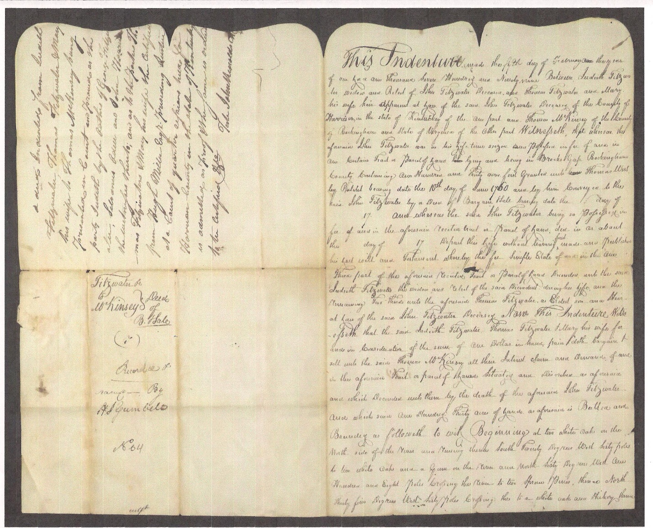

Document 1: This is the *face* of the original deed of 130 acres found in Stultz v McKensie in the Chancery Records Index, Virginia Memory, at the Library of Virginia, on page 57 of the pdf. , naming Thomas Fitzwater as the “Eldest son and Heir-at-law”.

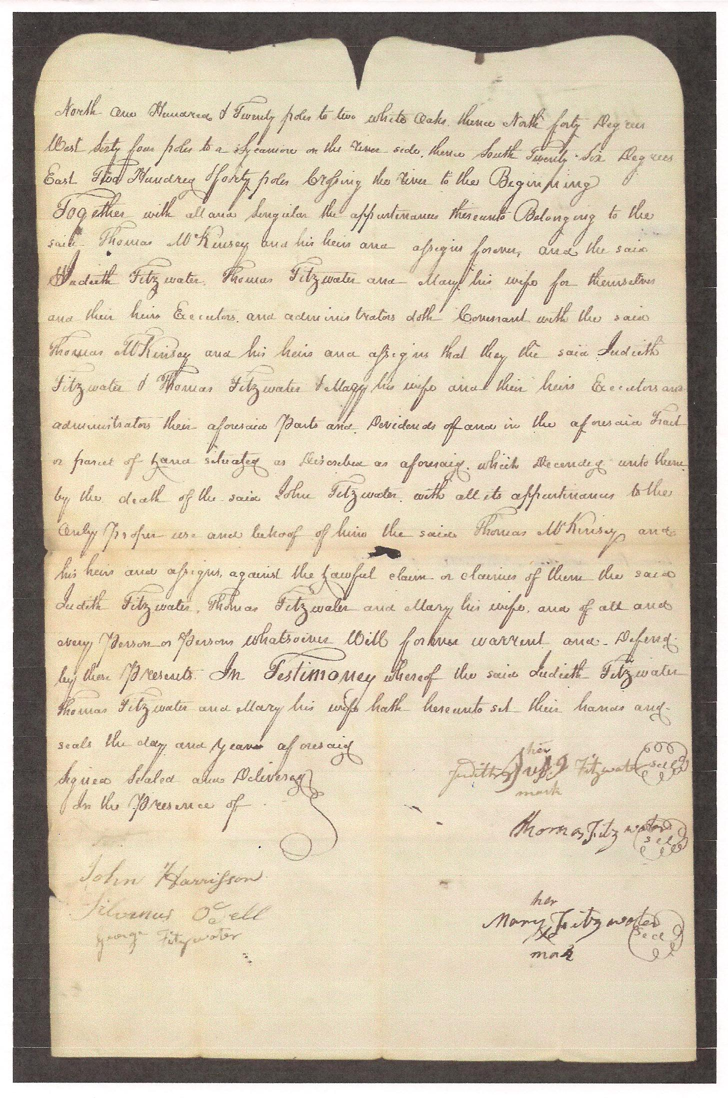

Document 1: This is the *signature* side of the above original deed of 130 acres found in Stultz v McKensie in the Chancery Records Index, Virginia Memory, at the Library of Virginia, on page 58 pdf.

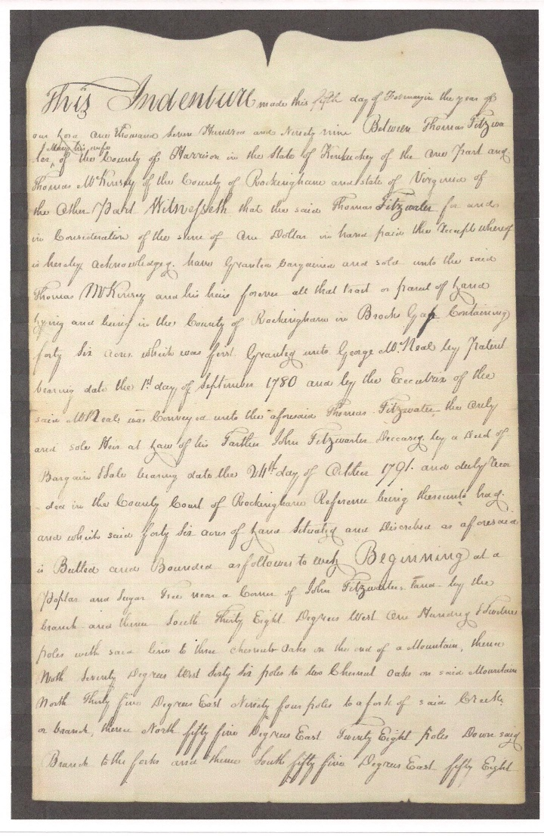

Shown above is Document 2: the *face* of the original deed of 46 acres contained in the Chancery Records Index, Virginia Memory, at the Library of Virginia on page 53 pdf.

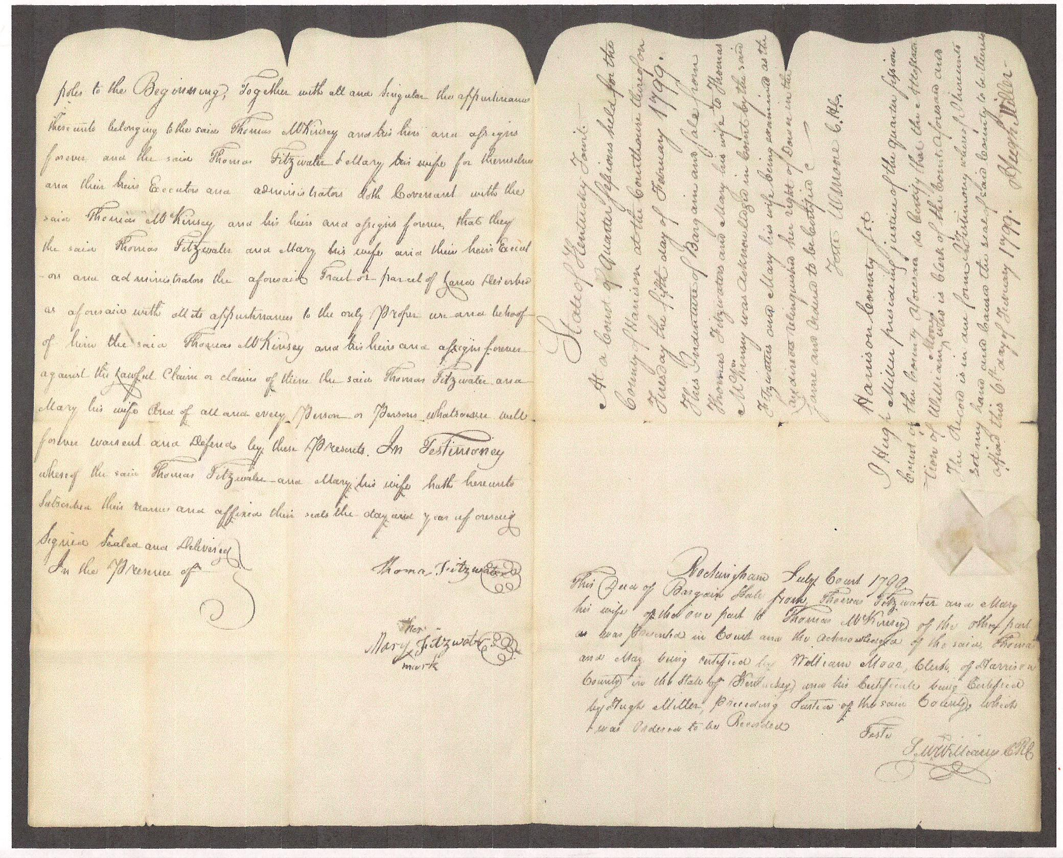 Document 2: This is the *signature* sideof the original deed of 46 acres, Chancery Records Index, Virginia Memory, Library of Virginia, page 54 pdf.

*Section 2*

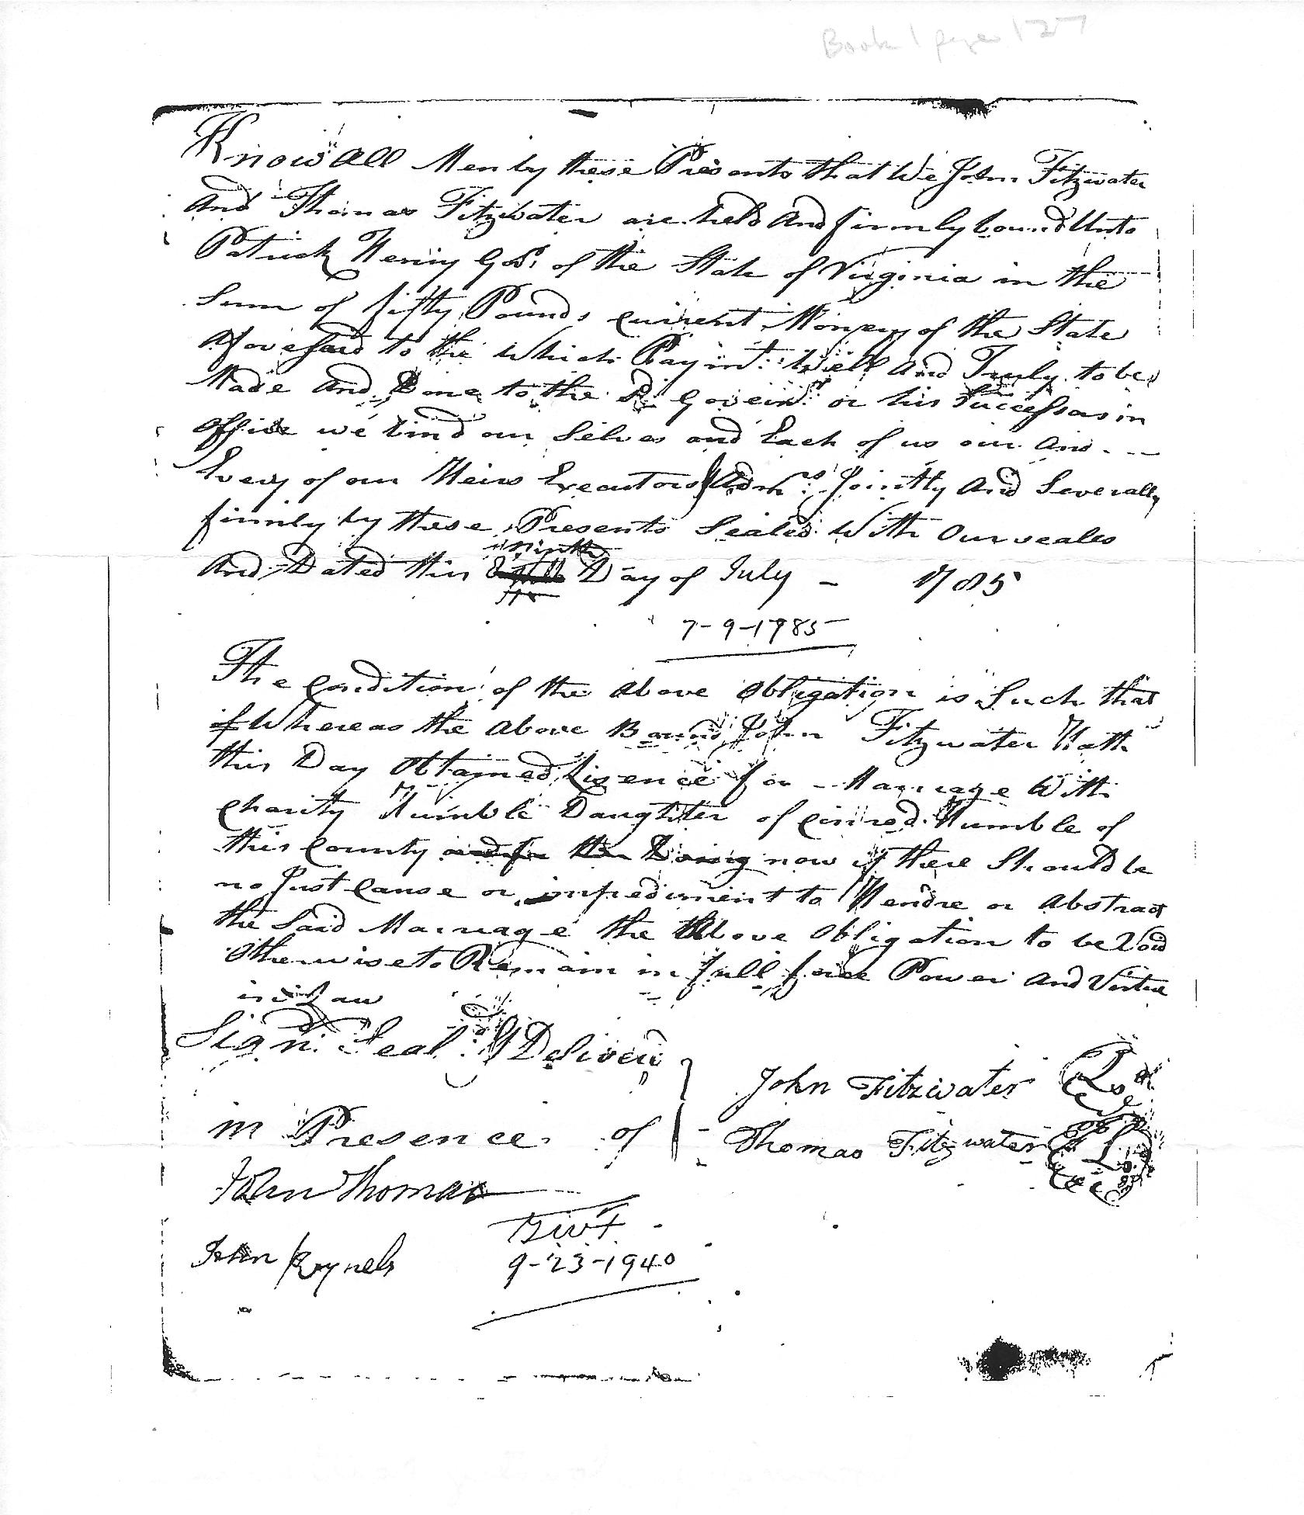

Document 1: The marriage bond of John Fitzwater, Jr. and Charity Humble.

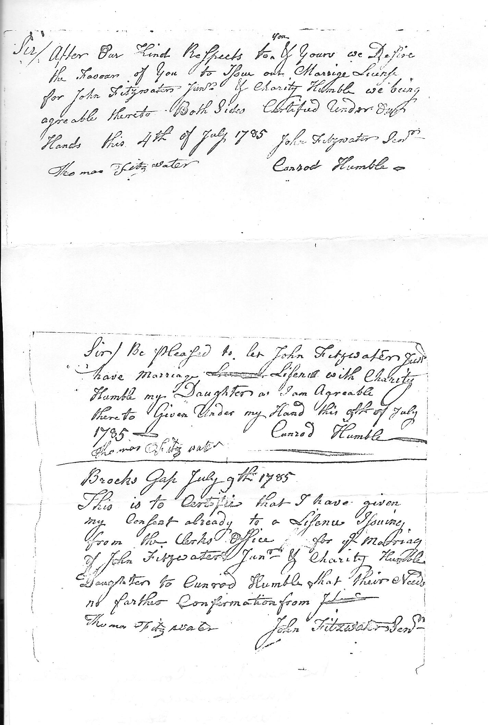

Document 2: The 3 consents signed by their respective fathers and witness Thomas Fitzwater.

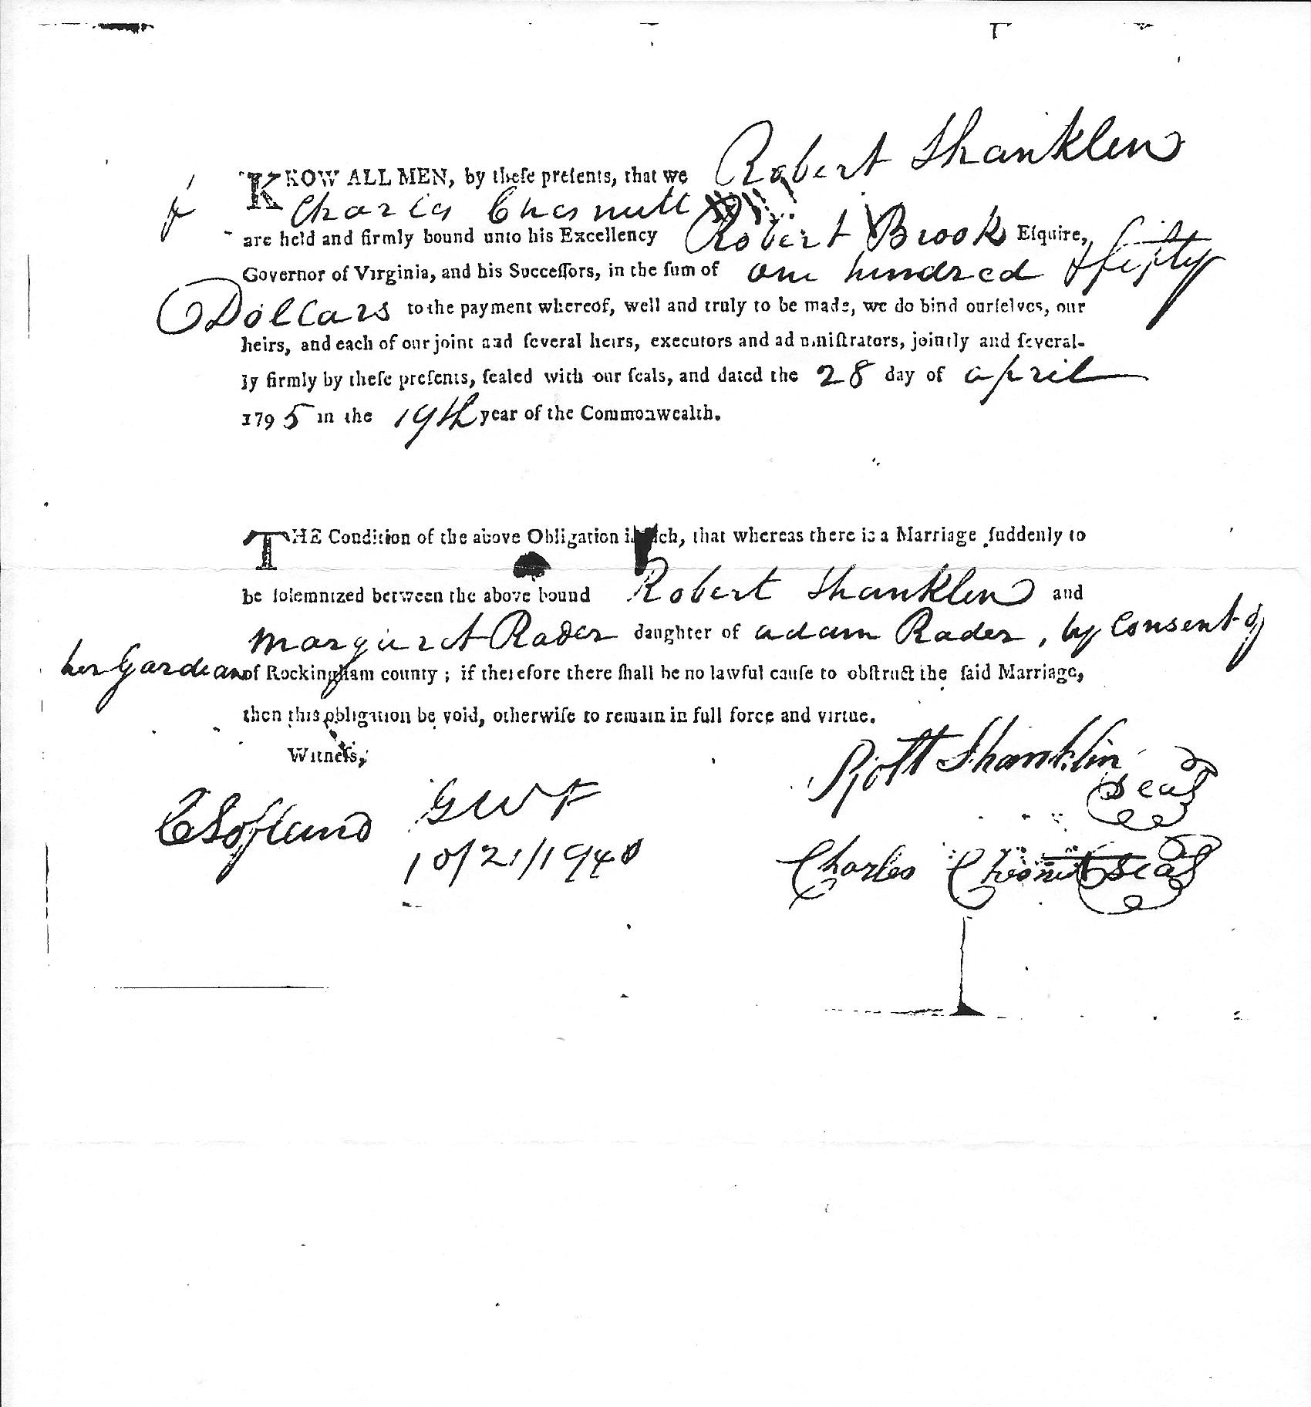

Document 3: the marriage bond of Robert Shanklin and Margaret Rader with consents indicated.

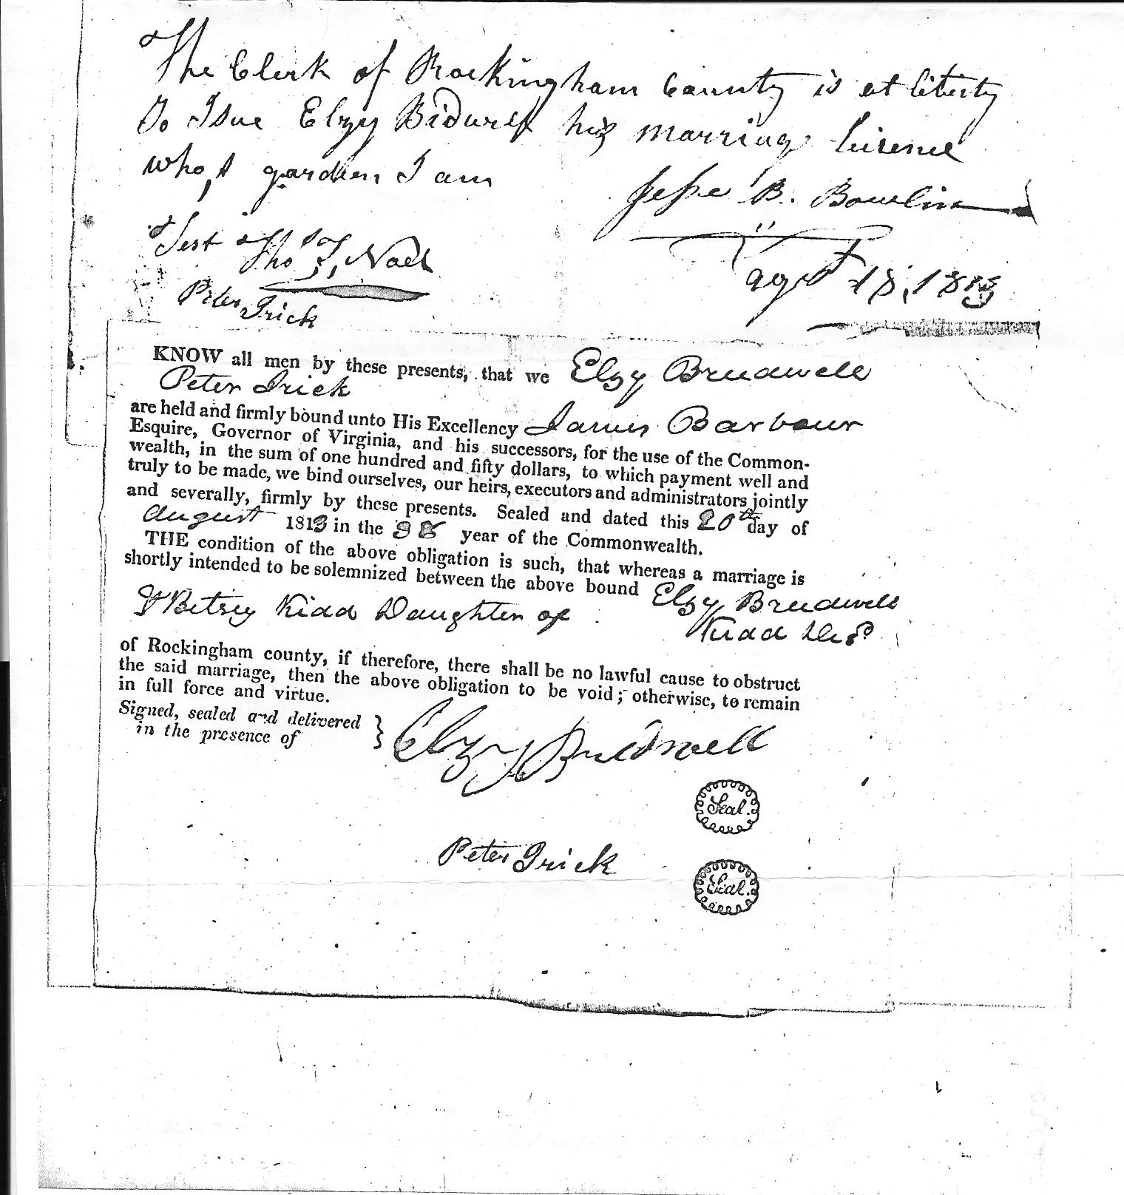

Document 4: the marriage bond of Elzy Bridwell and Betsy Kidd with consents indicated.

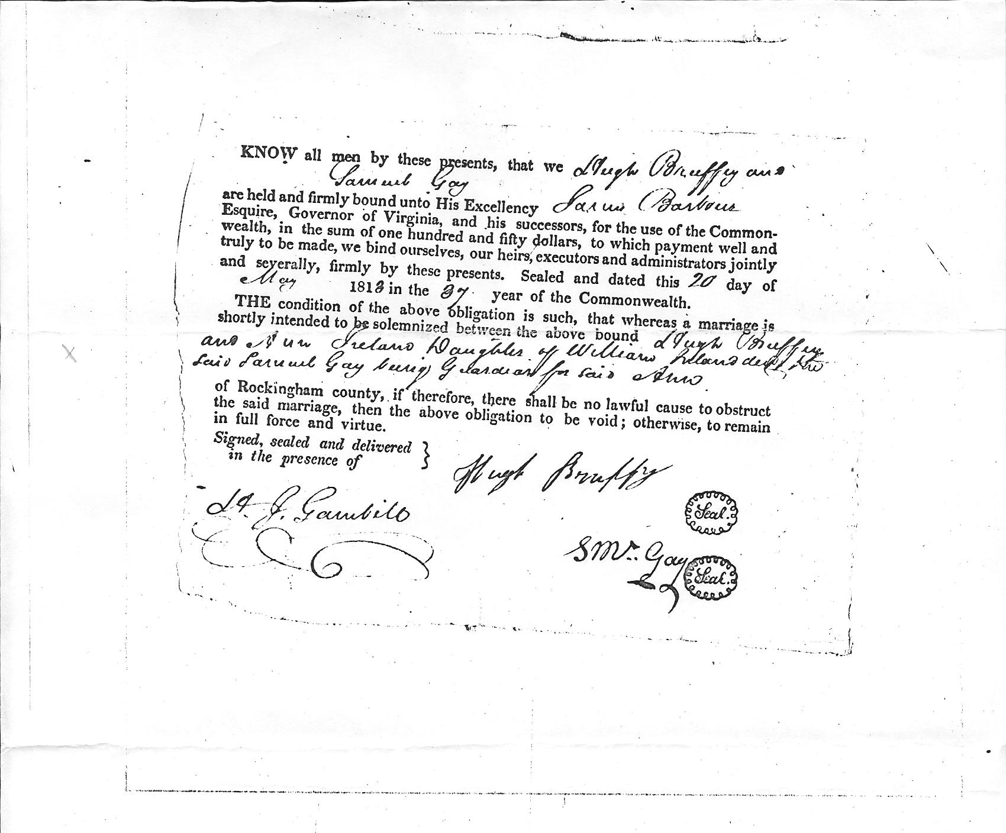

Document 5: the marriage bond of Hugh Bruffy and Anne Ireland with consents indicated.

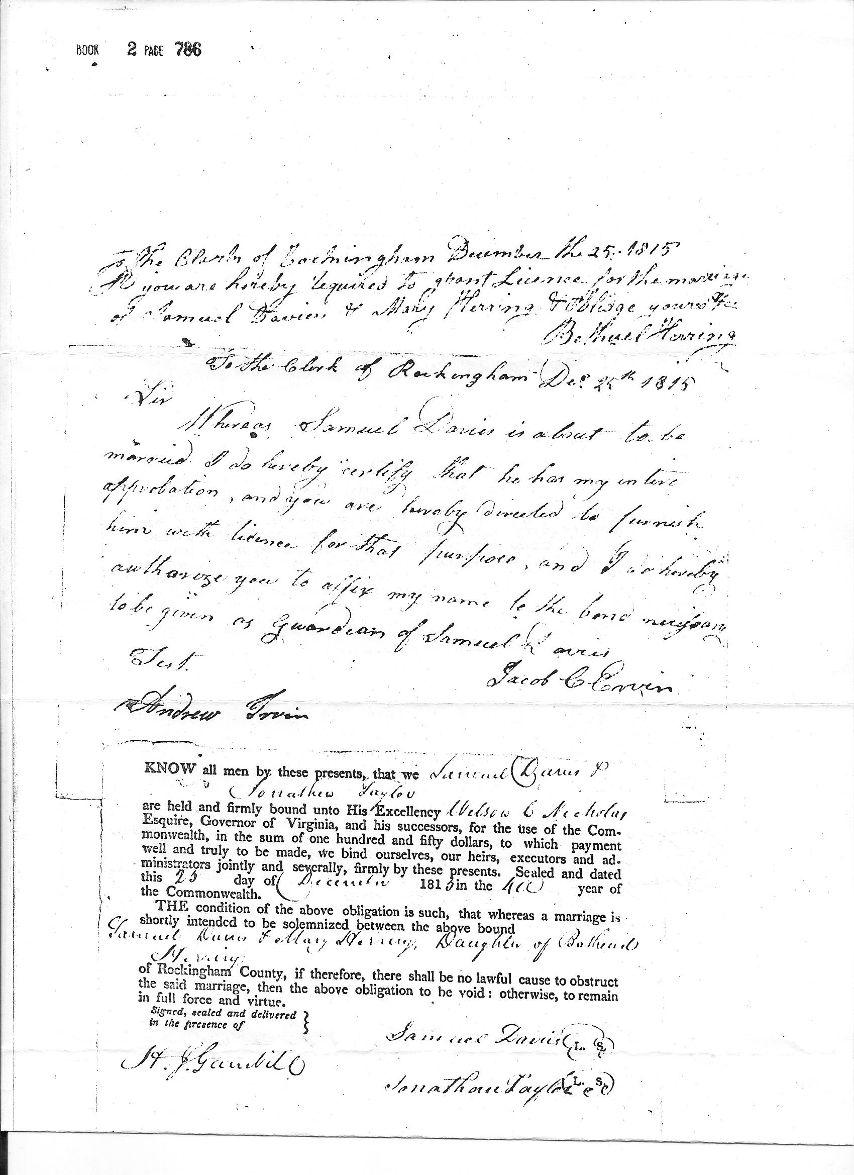

Document 6: the marriage bond of Samuel Davis and Mary Herring with consents indicated.

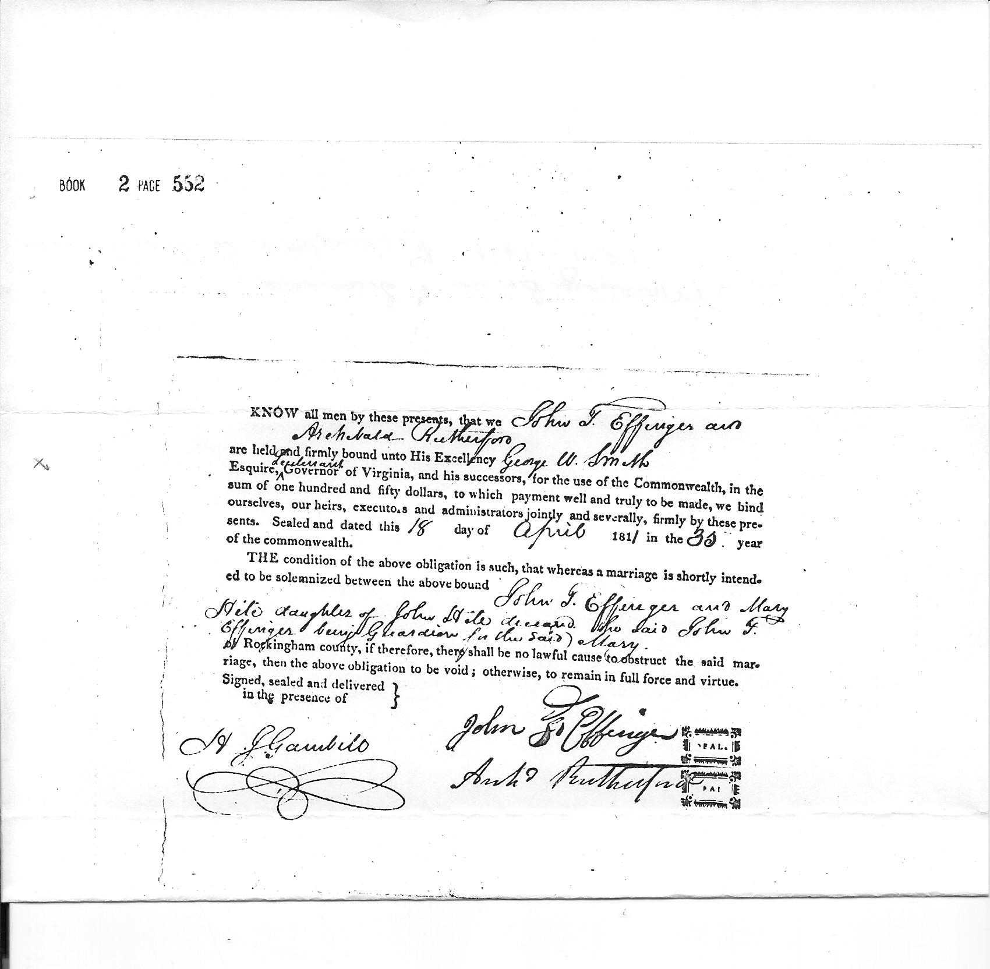

Document 7: the marriage bond of John Effinger and Mary Hite with consents indicated.

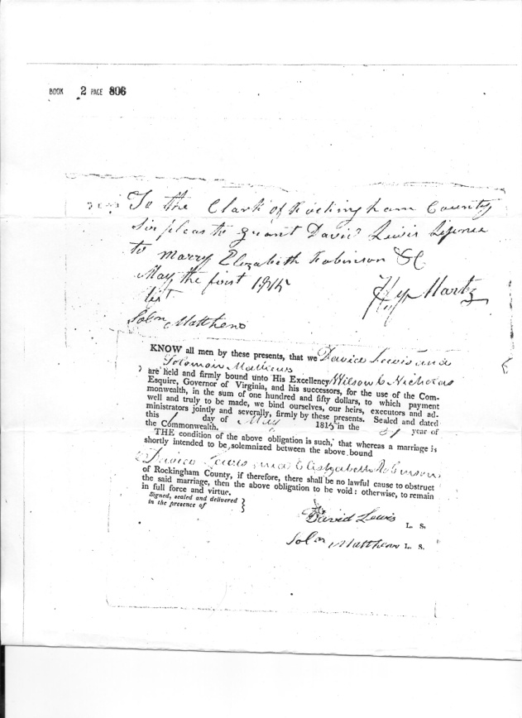

Document 8: the marriage bond of David Lewis and Elizabeth Robinson with consents indicated.

*Section 3*

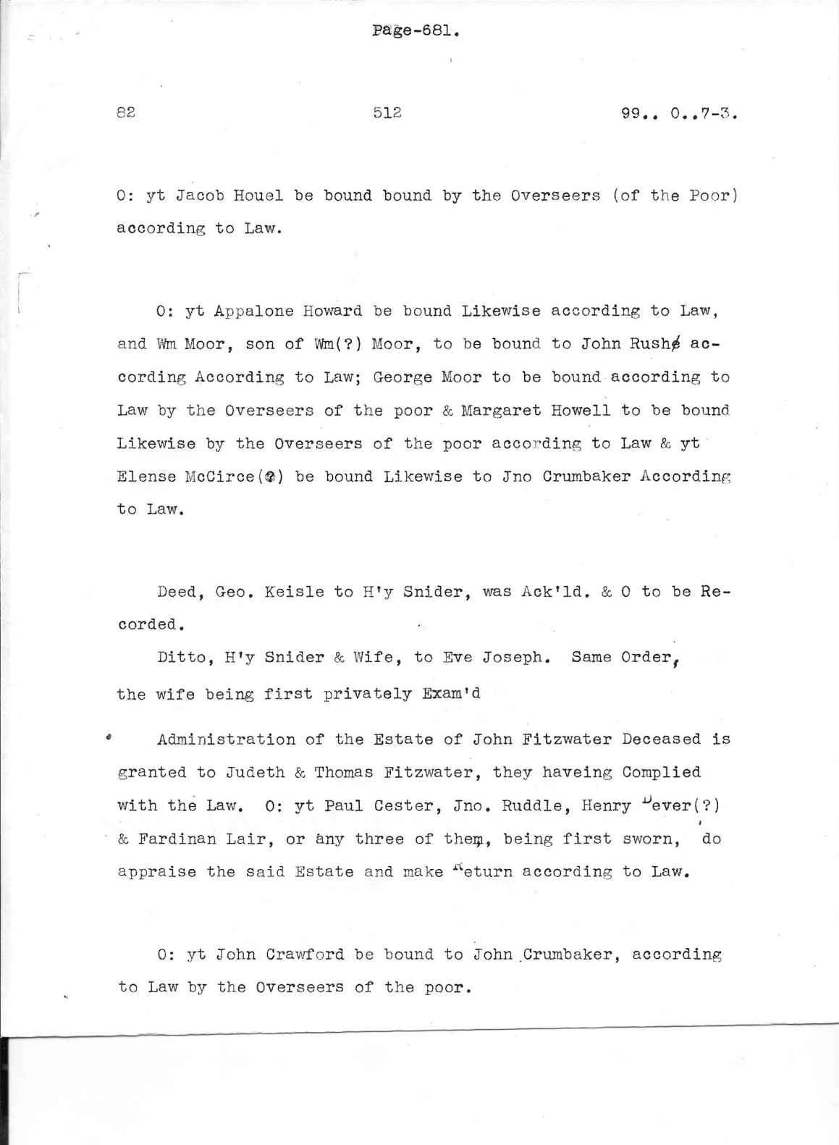

Document 1: Rockingham County Minute Book No.1, Vol. 2, page 681 transcripted showing Order of Administration of estate of John Fitzwater, Sr.

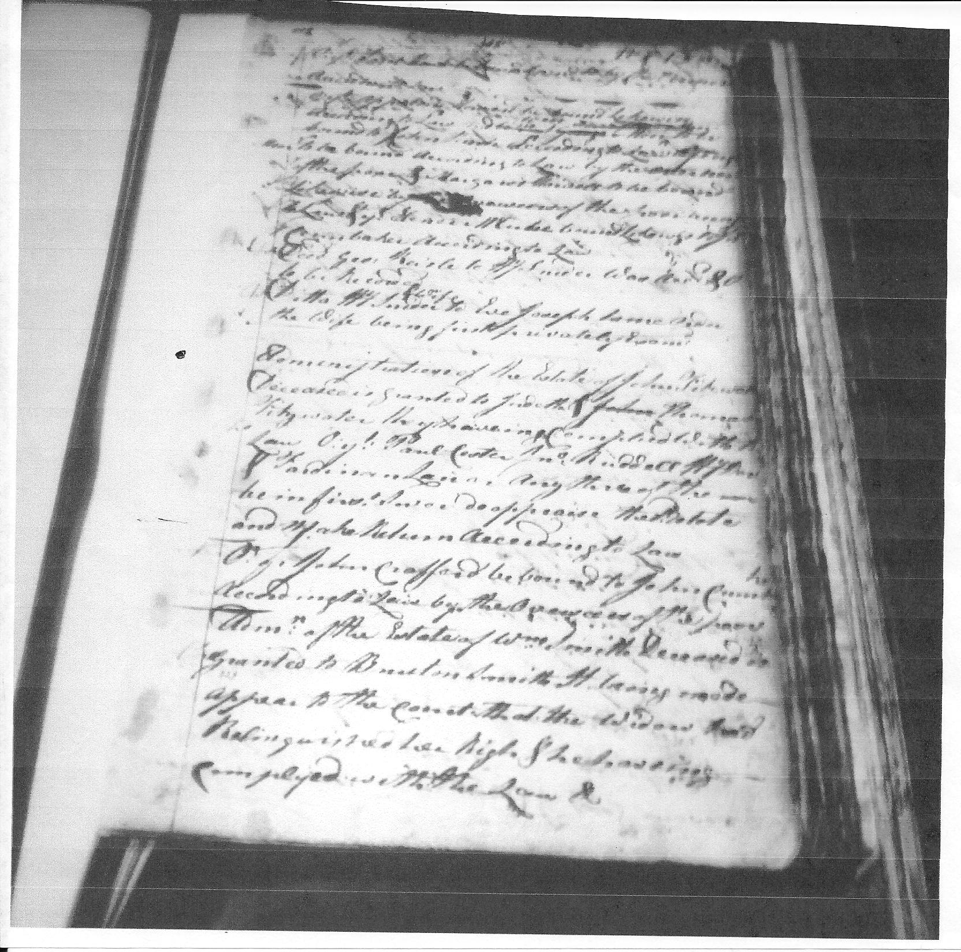

Document 2: Rockingham County Minute Book No.1, Vol. 2, handwritten original page 512 showing the Order of Administration of the estate of John Fitzwater, Sr. (note name John lined out by clerk).

Bibliography

Audrain County, Missouri, Probate Records Reel C49, Probate of the Estate of L S Hopkins, 1905

Augusta County VA, Chancery Causes, 1825-003, *Philip Stultz v Executors of Thomas McKenzie* original case number 118. Chancery Records Index, Virginia Memory, Library of Virginia, Richmond, VA. Pp. 53-58(pdf);

Augusta County, Virginia, Order Book 8, page 410; Augusta County Courthouse, Staunton, VA

Chalkley, Lyman. *Chronicles of the Scotch-Irish Settlement in Virginia Extracted from the original Court Records of Augusta County, 1745-1800* (Rosslyn, VA. 1912-1913 pp247-248);

Cook, Michael L. Virginia Supreme Court District of Kentucky, Order Books 1783-1792, [transcription] pg 56 [page 141 of original], Vol. 28 of Kentucky Records Series. Cook Publications: Evansville, IN

Devine, Katheryn Fitzwater. *Fitzwater Families of America* (Devine: Irvine, CA 1992. Pp26-29);

*Dickenson & others v. Holloway.* 6 Munf. 422, 20 VA 422;

Gentry, Daphne. *Chalkley’s Chronicles (VA Notes),* (Research in Virginia Documents, Publications and Education Division, Library of Virginia, Richmond, VA.);

Hening, William Waller. *The Statutes at Large; Being a Collection of All the Laws of Virginia from the First Session of the Legislature in the year 1619, pursuant to the Act of the General Assembly of Virginia February 5, 1808.* Published in New York by R&W&G Bartow: 1823,

<http://vagenweb.org/hening/vol1-18.htm> (Laws of VA, December 1656—7th of the Commonwealth, pg 416);

[http://vagenweb.org/hening/vol 2-01.htm](http://vagenweb.org/hening/vol%202-01.htm) (Cover showing Priestly Lecture);

[http://vagenweb.org/hening/vol 4-01.htm](http://vagenweb.org/hening/vol%204-01.htm) (Laws of VA, November 1711—9th Anne pp 15, 20);

[http://vagenweb.org/hening/vol 5-25.htm](http://vagenweb.org/hening/vol%205-25.htm) (Laws of VA, October 1748—22Geroge II pg 448);

[http://vagenweb.org/hening/vol 5-26.htm](http://vagenweb.org/hening/vol%205-26.htm) (Laws of VA, October 1748—22 George II pg 453);

[http://vagenweb.org/hening/vol 6-04.htm](http://vagenweb.org/hening/vol%206-04.htm) (Laws of VA, October 1748---22 George II pg 82);

[http://vagenweb.org/hening/vol 6-20.htm](http://vagenweb.org/hening/vol%206-20.htm) (Laws of VA—August 1754—28 George II pg 429);

<http://vagenweb.org/vol12-07.htm> (Laws of VA--October 1785-10th of the Commonwealth, pp 138, 146);

Keim, C. Ray. *Primogeniture and Entail in Colonial Virginia*. William and Mary Quarterly, Third Series, Vol. 25, No. 4 (Oct. 1968), Pp 545-586. (Published by the Omohundro Institute of Early American History and Culture at stable URL: <http://www.jstor.org/stable/1916798> );

Levinson, Constance A, and Levinson, Louise C. *Rockingham County, Virginia, Minute Book 1778-1792 Part I 1778-1786,* Greystone Publishing: Harrisonburg, VA Pp34, 35

Library of Virginia. *Using County and City Court Records in the Archives of the Library of Virginia (Research Note 6)*; Published by the Library of Virginia at [www.lva.virginia.gov/public/guides/rn6_localrecs.htm](http://www.lva.virginia.gov/public/guides/rn6_localrecs.htm). ;

Nelson, Thomas Forsythe. *Report on the Chalkley Manuscripts, 21st Congress, the National Society Daughters of the American Revolution.* 1912. Genealogy and Local History LH199. Heritage Quest.

Priode, Margaret. *Abstracts of Executor, Administration, and Guardian Bonds of Rockingham County, VA 1778-1864.* , published by the Harrisonburg-Rockingham Historical Society. Harrisonburg, VA: 1978. Pp 1-22.

*The Revised Code of the Laws of Virginia; Being a Collection of All Such Acts of the General Assembly, of a Public and Permanent Nature, As Are Now In Force, With a General Index. Published Pursuant to an Act of the General Assembly entitled “An act providing for the republication of the Laws of this Commonwealth*,” passed March 12, 1819. Volume 1. Richmond, VA. Printed by Thomas Ritchie: 1819. Pp 355-358; (Google Open Library).

Rockingham County, Virginia, Marriage Bonds Book 1 Pp 127, 645; Book 2 Pp 552, 680, 786, 806

Rockingham County, Virginia, Minute Book (original handwritten) 1778-1792 Vol 1 part 2 page 681; LDS microfilm #2080027 Items 2 and 3 filmed by the Library of Virginia 1983.; Church of Latter Day Saints, Salt Lake City, UT.

Rockingham County, Virginia, Minute Book (transcription) 1778-1792 Vol 1 Part 2 P 681

Strickler, Harry M. *Old Tenth Legion Marriages: Marriages in Rockingham County, Virginia, From 1778-1816, Taken from the Marriage Bonds.* Genealogical Publishing Co., Inc. Baltimore: 1986. Pp 6-105.